Ethernet standard and specification

Task 1 :- Draw a simple diagram showing the pin layout of an RJ-45 connector and label the color codes for the T568A and T568B Ethernet wiring standards.

ANS :-

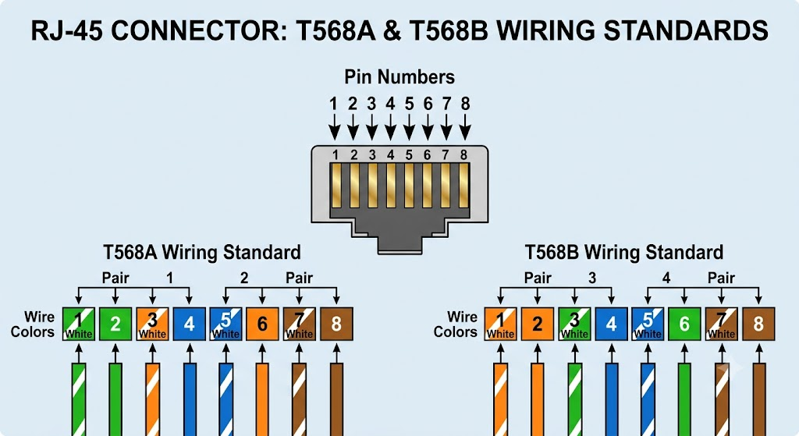

Task 2 :- Create a table comparing the key specifications of Ethernet standards 10BASE-T, 100BASE-TX, and 1000BASE-T, including speed, cable type, maximum cable length, and connector type.

ANS :-

Specification | 10BASE-T | 100BASE-TX (Fast Ethernet) | 1000BASE-T (Gigabit Ethernet)
Data Transfer Speed | 10 mbps | 100 mbps | 1000 mbps  (1 gbps )
Cable Type (Minimum) | Category 3 (cat3)/higher | Category 5 (Cat 5) / higher | Category 5e (Cat 5e) / higher
Maximum Segment Length | 100 meters (328 feet) | 100 meters (328 feet) | 100 meters (328 feet)
Connector Type | RJ-45 | RJ-45 | RJ-45
Wire Pairs Used | 2 pairs (4 wires) | 2 pairs (4 wires) | 4 pairs (8 wires)
Encoding Scheme | Manchester encoding | 4B5B / MLT-3 | PAM-5

Task 3 :- Given a scenario where you need to connect two laptops directly using Ethernet, explain which cable (straight-through or crossover) you would use and why.

ANS :-

Any Cable (Straight through) :-
Almost all laptops made in the last 15–20 years support a feature called Auto-MDI/MDIX. This allows the network card to automatically detect that it's connected to another laptop and swap the signal paths internally. Because of this, a regular straight-through cable works completely fine today.

Task 4 :- List three real-world devices in your home or college that use Ethernet connections, and for each, specify the likely Ethernet standard (e.g., 100BASE-TX, 1000BASE-T) they support.

ANS :-

Desktop Computer / Laptop :-

- Likely Ethernet Standard: 1000BASE-T (Gigabit Ethernet)
- Speed: Up to 1 Gbps (1000 Mbps)

Smart TV :-

- Likely Ethernet Standard: 1000BASE-T or 100BASE-TX (Fast Ethernet)
- Speed: Up to 1 Gbps or capped at 100 Mbps depending on the model

Wi-Fi Router / Network Switch :-
- Likely Ethernet Standard: 1000BASE-T (Gigabit Ethernet)
- Speed: Up to 1 Gbps per port

